AnKaLu Tetris

Software Architecture Document

Version <1.0>

Revision History

|  |  |  |  |
| --- | --- | --- | --- |
| **Date** | **Version** | **Description** | **Author** |
| 29.11.2016 | 1.0 |  | André Harbrecht  Katharina-Maria Heer  Luka Kröger |
|  |  |  |  |
|  |  |  |  |
|  |  |  |  |

Table of Contents

1. Introduction 4

1.1 Purpose 4

1.2 Scope 4

1.3 Definitions, Acronyms, and Abbreviations 4

1.4 References 4

2. Architectural Representation 4

3. Architectural Goals and Constraints 4

4. Use-Case View 4

5. Logical View 5

6. Process View 5

7. Deployment View 5

8. Implementation View 5

9. Data View (optional) 5

10. Size and Performance 6

11. Quality 6

Software Architecture Document

# Introduction

## Purpose

This document provides a comprehensive architectural overview of the system, using a number of different architectural views to depict different aspects of the system. It is intended to capture and convey the significant architectural decisions which have been made on the system.

## Scope

## Definitions, Acronyms, and Abbreviations

## References

* [Github](https://github.com/AlSalad/Ankalu)
* [Blog](https://ankalublog.wordpress.com/)

# Architectural Representation

AnKaLu uses a different sort of ‘architecture’ because Tetris is a game and needs to be updated periodically.

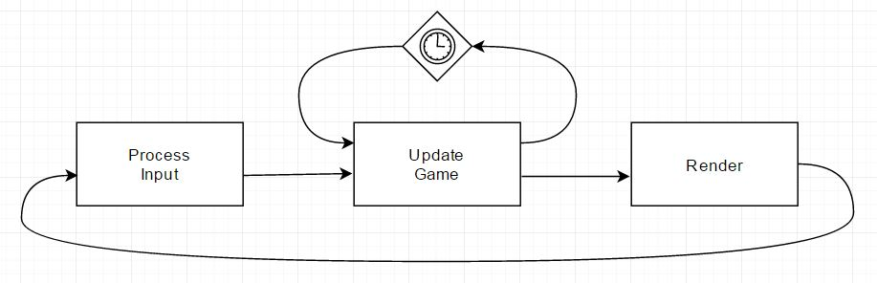

# Architectural Goals and Constraints

As we are not using any specific standardized architecture, we decided to create the representation by hand.

# Use-Case View

(N/A)

# Logical View

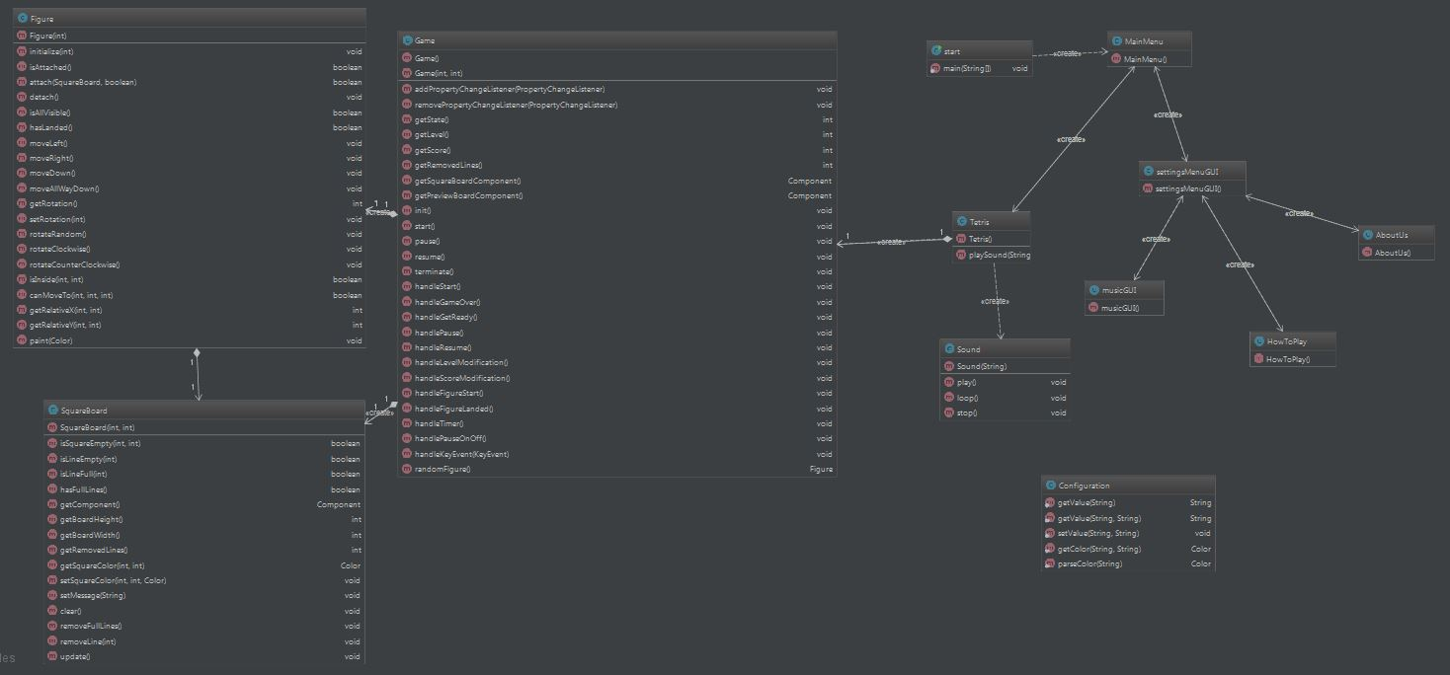

# Process View

(N/A)

# Deployment View

(N/A)

# Implementation View

(N/A)

# Data View

(N/A)

# Size and Performance

(N/A)

# Quality

(N/A)